At GrupoDC Solutions, company specialized in Security consulting, we are aware of the importance and the need of continuous improvement. That is why we have decided to set a policy of respect to quality standards and ongoing improvement of our services in every area of business management.

GrupoDC Solutions’ Direction commits itself to:
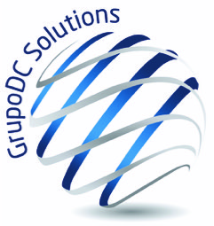
Establish a Quality Management System under the label “Consulting and training Services on Security matters”, based on the UNE-EN ISO 9001:2015 and ISO 31000, both addressed to guarantee the correct situation of the facilities and to reach the full satisfaction of the clients, including:

- Compliance of the requirements requested by the client, legal requirements and internal requirements defined by the organization.
- A continuous effort in improving the identification, evaluation and mitigation of any adverse effect our activity may produce.
- The elaboration of plans and programs which establish specific goals, to ensure that the processes are developed guaranteeing the quality of the rendered services, and the performance of internal audits to reduce risks and non-requested products, minimize negative effects on quality, regularly control the effectiveness and positive impact of the new measures applied, as well as to enhance the culture of continuous improvement of processes and practices inside the company.

Effectively establish and maintain the aforementioned Quality Management System, informing of the principles and commitments of the Quality Policy to all the organizational levels, as well as to providers, clients and contractors, so the whole policy is acknowledge, implemented and kept by all the involved stakeholders.

Train each employee on quality issues, developing tailored training programs to guarantee his professional skills and competencies in the development of his tasks.

Ensure that every activity, product and service is developed according to the set framework of this Quality Policy.

Prevent, or at least mitigate, the detrimental aspects derived from our activities, products and services.

Advance in the knowledge and Quality improvement of the whole organization.

In this sense, every member of the organizations has an additional condition to implement in his job: to ensure our clients’ satisfaction. This Policy is freely accessible to the public and it is reviewed and updated on regular basis to its continuous adequacy.

